Research About The Game build plan:
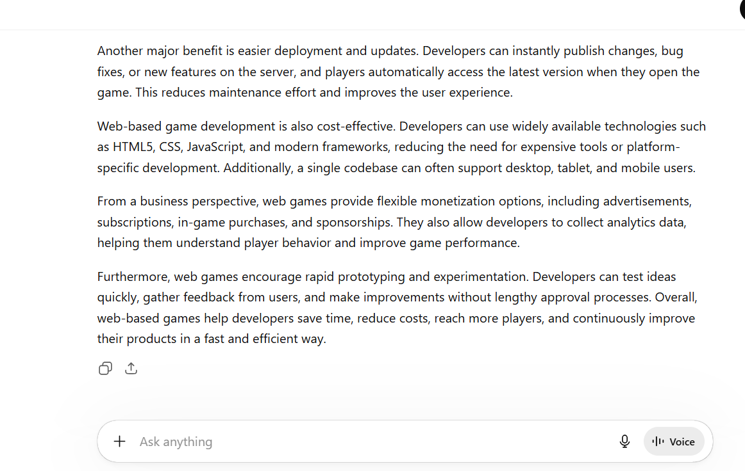

This is the evidence of the research that I have done in the group project in the first week. This image shows that why we pick the Web based game rather that the app based game.

